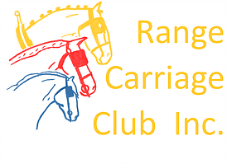
Range Carriage Club Inc

Indoor-Outdoor Event

Sunday 8th March,2020
Goombungee Showgrounds
Each driver must complete a separate entry form.

Camping and stabling can be on one form.
Goombungee

ENTRY FORM

Name: -----------------------------------------------------

Phone: -----------------------------------------------

Email--------------------------------------------------------

ACDS Affiliated Club--------------------------------------ACDS Member No: ----------------

Junior Driver: YES/NO If yes DOB: ---------------------Name of Groom

(experienced driver who is an ACDS member) ----------------------------------

Groom member No: ------------------------

Entry Fee: $40 per driver/horse combination for the day. Free entry for juniors.
Class | Horse/pony name | ACDS Reg # | Horse/pony height |  | Wheel width | Horse /pony age | Fee
 | Have you sent payment via direct deposit Yes/No |  |  | Total enclosed

All competitors and their navigators/grooms compete at their own risk. Neither the ACDS, nor their appointed officials accept any liability for any accident, theft, illness or damage to horses, grooms or any person or property whatsoever. All competitors, by entering this event, agree to be bound by this regulation. I am aware of and agree to pay the excess that applies to any insurance claim which may arise from participating in this even
Competitor signature:_______________________ Date:_________________
Parent/guardian signature (if under 18 years old):______________________________

Entries close Thursday 5 March 2020. Direct deposit to
Range Carriage Club Inc
BSB 638070
Account No 13212605

