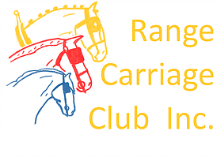
Range Carriage Club Inc

Mini Enduro

Sat 2nd – Mon 4th May,2020
Goombungee Showgrounds
Goombungee

ENTRY FORM

Name: -----------------------------------------------------

Phone: -----------------------------------------------

Email--------------------------------------------------------

ACDS Affiliated Club--------------------------------------ACDS Member No: ----------------

Junior Driver: YES/NO If yes DOB: ---------------------Name of Groom

(Experienced driver who is an ACDS member) ----------------------------------

Groom member No: ------------------------

Entry Fee: $60 per driver/horse combination for the 3 days (includes Fri night BBQ). Free entry for juniors.
Class | Horse/pony name | ACDS Reg # | Horse/pony height |  | No of days(1-3) | Horse /pony age | Fee
 | Have you sent payment via direct deposit Yes/No |  |  | Total enclosed

All competitors and their navigators/grooms compete at their own risk. Neither the ACDS, nor their appointed officials accept any liability for any accident, theft, illness or damage to horses, grooms or any person or property whatsoever. All competitors, by entering this event, agree to be bound by this regulation. I am aware of and agree to pay the excess that applies to any insurance claim which may arise from participating in this even
Competitor signature:_______________________ Date:_________________
Parent/guardian signature (if under 18 years old):______________________________
Entries close Saturday April 25th 2020. Direct deposit to
Range Carriage Club Inc
BSB 638070
Account No 13212605

